Title I, PART A COMPRABILITY: CHARTER HOLDER ATTESTATION STATEMENT

THE PURPOSE OF THIS FORM:

- To provide a statement that explains how the charter holder allocates resources equitably to all campuses, regardless of Title I, Part A status.

- To provide an attestation that the resource allocation plan for the charter holder is compliant with Title I, Part A requirements.

---------------------------------------------------------------------------------------------------------------------

CHARTER HOLDER NAME: Nevada Rise

SCHOOL YEAR: 2023-2024

STATE FISCAL YEAR: FY 24

CHARTER HOLDER’S RESOURCE ALLOCATION STATEMENT:

The Board of Nevada Rise Academy Charter School certifies that Nevada Rise Academy is a one-campus school, and receives Title I funds, as well as state and local funds, to provide services that, taken as a whole, are equitably available for the needs of the campus.

By signing below, the certifying official affirms that the charter holder’s resource allocation statement is accurate and in compliance with Title I, Part A Comparability requirements. In addition, the certifying official attests that they are a charter school administrator whose salary and/or benefits are not paid wholly, or in part, with Title Ⅰ, Part A funds.

Justin Brecht
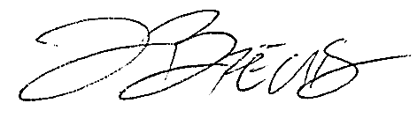
Printed Name of Certifying Official

______________________________ November 27, 2023
Signature of Certifying Official Date

