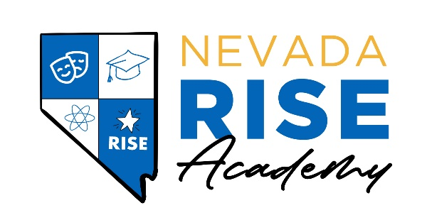

TO: Whom It May Concern

RE: Annual Staffing and Budget Comparison Report
___________________________________________________________________________

In compliance with NRS 387.12468 requiring each public school to create a report that includes a description of the personnel employed and services provided during the immediately preceding school year and any changes the school anticipates making to the personnel and services during the current school year, please see below.

Nevada Rise employees educators and support staff to deliver instruction to kindergarten through 5th grade students and perform actions and duties to carry out the school mission of Nevada Rise. We do not anticipate making changes to personnel structure of services in the near future.

Thank you,
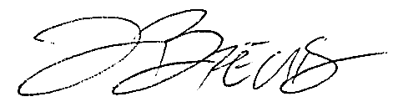
Justin Brecht
Executive Director
Nevada Rise Academy

