Title I, Part A: Non-Supplanting Charter School Attestation Template

Supplanting Defined
Title I, Part A federal funds must be used to supplement, not supplant (SNS) existing funds for program activities and must not replace those funds that have been appropriated for the same purpose. Generally, federal funds allocated to are supposed to be additive or supplemental to other funds available to schools. “Non-federal funds,” means only public “state and local funds.” Accordingly, other non-Federal funds, such as private contributions, fundraising, and parent fees, need not be part of determining compliance with the Title I, Part A supplement, not supplant requirement, unless the Nevada Department of Education or SPCSA requires that they be included.

Supplanting shall be the subject of application review, reimbursement request review, amendment review, post-award monitoring, and/or audit reviews. If there is a potential presence of supplanting, the charter holder applicant or grantee will be required to supply documentation demonstrating that the reduction in non-federal resources occurred for reasons other than the receipt or expected receipt of Federal funds. ESEA section 1118(b)(1)

CHARTER HOLDER ATTESTATION STATEMENT

Nevada Rise Academy certifies that any funds awarded through Title I, Part A shall be used to supplement existing funds for program activities and will not replace (supplant) state and/or local funds that have been appropriated for the purposes and goals of the grant.

Nevada Rise Academy understands that supplanting violations may result in a range of penalties, including but not limited to suspension of future Title I, Part A funds, suspension or debarment from federal grants, recoupment of monies provided under this grant, and civil and/or criminal penalties.

Justin Brecht
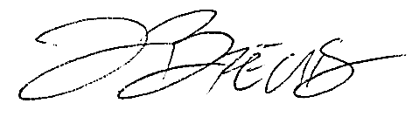
Printed Name of Certifying Official

_______________________________________________ October 8, 2023
Signature of Certifying Official Date

