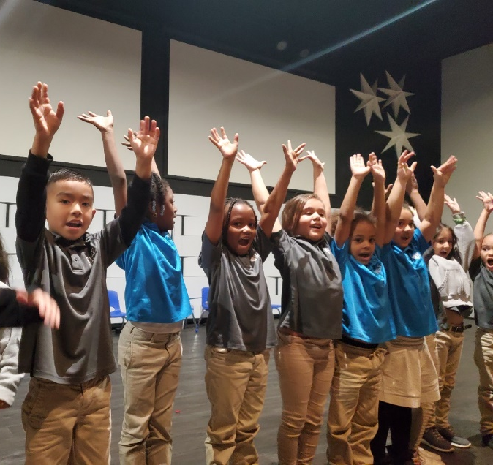
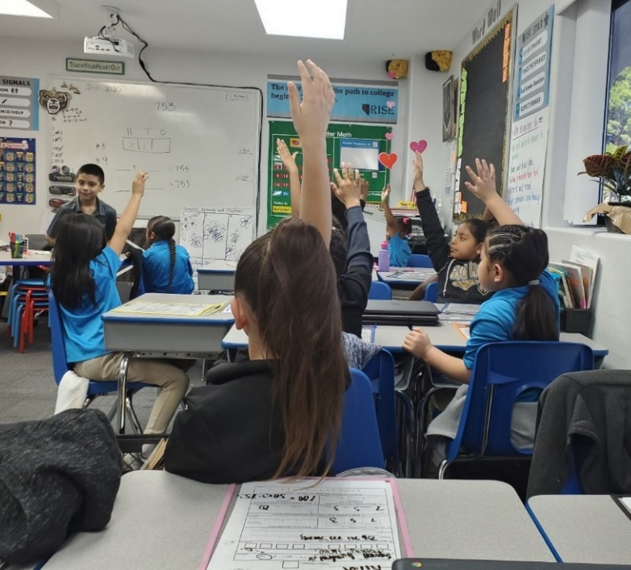

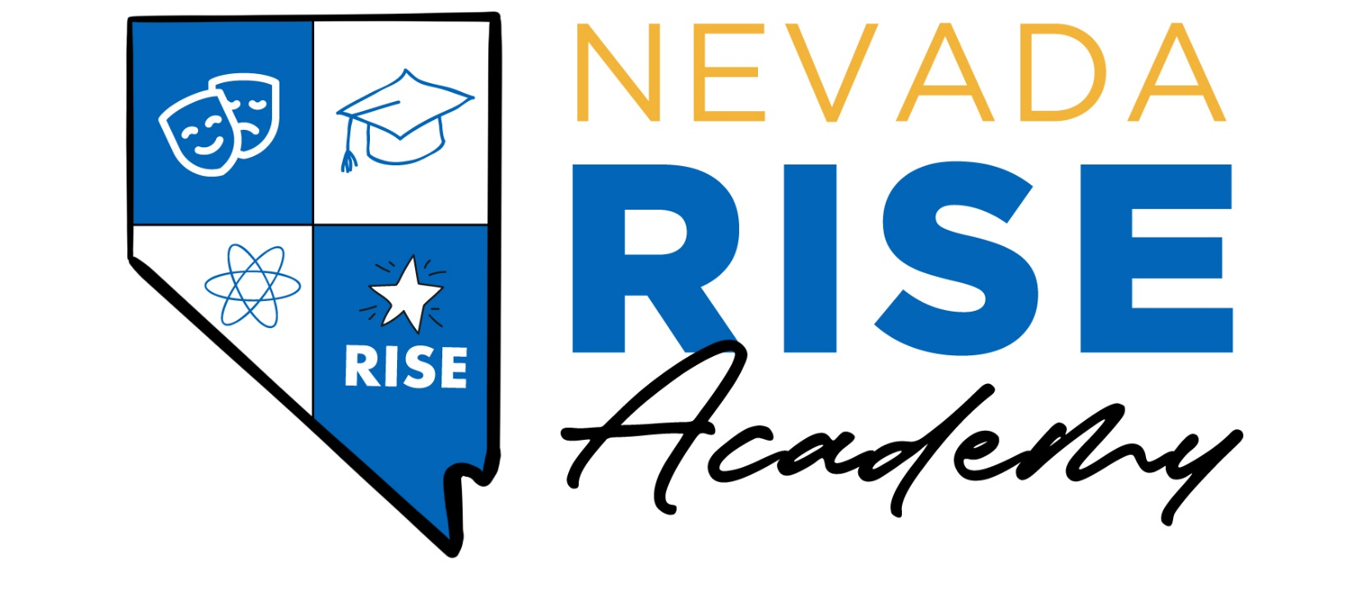

COVID-19 Mitigation Plan
Emergency Directive 052
Academic and Operational plans for a safe learning environment in response to the COVID-19 pandemic.
Updated February 2022

Overview and Purpose of this Document
On April 19, 2021, Governor Sisolak issued Declaration of Emergency Directive 044 requiring the Superintendent of Public Instruction to update the requirements and provide written guidance to county school districts and State and district sponsored charter schools (“districts and schools”) regarding reopening plans and plans for Path Forward Programs of Distance Education for the 2021-22 school year
On February 10, 2022, Governor Sisolak issued Emergency Directive 052. Per Section 4 of the Directive:
“Each county school district, charter school, and private school shall adopt a COVID-19 mitigation plan. The plan must include:
- A policy on whether and under what circumstances face coverings will be required for students and staff while in school buildings or on school campuses;
- 2. A regular COVID-19 testing program for students and staff or volunteers, including but not limited to coaches, leaders, and advisors. If a student, staff member, or volunteer tests positive for COVID-19, current CDC recommendations for isolation and quarantine must be followed; and
- 3. A method for detecting school-wide outbreaks of COVID-19 and a plan for responding to and mitigating the outbreak.”
The following takes into consideration guidance from the Center for Disease Control, the Southern Nevada Health District, and the Nevada Department of Education document “Nevada’s Path Forward: A Framework for a Safe, Efficient, and Equitable Return to School Buildings.” Additionally, guidelines and suggestions from the following resource: COVID-19 Handbook Volume 1: Strategies for Safely Reopening Elementary and Secondary Schools, COVID-19 Handbook, Volume 2: Roadmap to Reopening Safely and Meeting All Students' Needs, and Operational Strategy for K-12 Schools through Phased Prevention
It is important to remember that this document is a set of guidelines and a plan that will most likely be revised on a continual basis. The circumstances surrounding COVID-19 are ever-changing, and we will make every effort to adapt and modify as necessary.

CRISIS & EMERGENCY RESPONSE PLANS
- Nevada Rise Academy has developed an Emergency Operations Plan, updated with procedures for protocols for pandemic and infectious disease. These plans meet the Nevada Requirements for Crisis and Emergency Response for Schools in Nevada public, private and charter schools and the federal definition of a high-quality school EOP; in addition to Nevada Revised Statutes (NRS) requirements (NRS 388.229 - .261 Public Schools) and were submitted in July 2021.

NEVADA RISE ACADEMY: 2021-2022 School Year Plan
RE-OPENING APPROACH
The approach described below is guided by the following principles:
- Working within recommendations from Southern Nevada Health District/Center for Disease Control while following the guidance from the State Public Charter School Authority, and the requirements from the Nevada Department of Education.
- Maximizing in-person, consistent learning in mind
- Incorporating Parent/Family input in options
- Equality in the choice- all students receive the same education.

IN-PERSON LEARNING: HEALTH AND SAFETY
Safety of educators and students will remain our priority. We will maintain efforts from our initial re-opening plans from the spring of 2021, while utilizing increased resources and updated guidelines.

USE OF FACE COVERINGS & SOCIAL DISTANCING
Nevada Rise will follow all state mandates and update the policy accordingly. In response to Emergency Directive 052, as of February 10, 2022:
All staff and students are required to wear well-fitting face coverings with proper filtration throughout the school day.

Exceptions will be made for outside activities, eating and drinking, and any documented medical reasons. Nevada Rise will keep a supply of face coverings (both masks and shields) for all school community members (staff, student, parent, partner, volunteer). We also sell Nevada Rise-branded face coverings.

To the extent possible, students will socially distance. Space limitations within our facility restrict the amount of space between students at all times, but through the use of physical barriers, every effort will be made to mitigate transmission.

PHYSICAL HEALTH SCREENING
Any person (student, staff, parent, volunteer, etc.) who has a fever of 100.4F or above or demonstrates other signs of illness will not be admitted on campus. Nevada Rise will encourage parents to be on the alert for signs of illness in their children and to keep them home when they are sick. Nevada Rise Academy will implement all CDC examples of screening methods to assist in a screening plan.
- Daily Screening:
- Nevada rise will screen all students daily during arrival with a thermometer reading.
- Ask parents/guardians to take their child’s temperature either before coming to the facility or upon arrival at the facility. Upon their arrival, stand at least 3 feet away from the parent/guardian and child.
- Make a visual inspection of the child for signs of illness which could include flushed cheeks, rapid breathing or difficulty breathing (without recent physical activity), fatigue, or extreme fussiness.
- All staff record temperatures on our log sheet located in front office. Operations team will ensure 100% of staff and contracted partners are screened.

- Reliance on Barrier/Partition Controls, and Personal Protective Equipment (PPE) Where/When Possible & Practical
- Stand behind a physical barrier or use PPE that can serve to protect the staff member’s face and mucous membranes from respiratory droplets that may be produced if the child being screened sneezes, coughs, or talks.
- Make a visual inspection of the child for signs of illness
- Conduct temperature screening, perform hand hygiene, wash hands with soap and water for 20 seconds or use a hand sanitizer with at least 60% alcohol.
- Use non-contact thermometers only.

Screenings will be conducted safely and respectfully, and with measures in place to ensure confidentiality. If a case is confirmed on campus, we will follow the CDC protocol below:
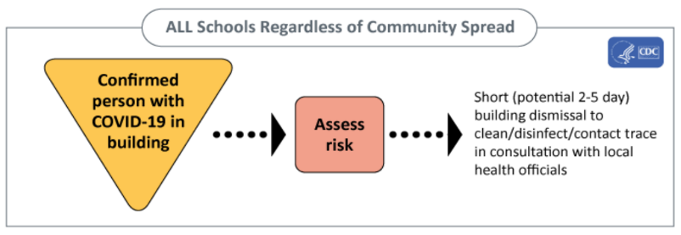
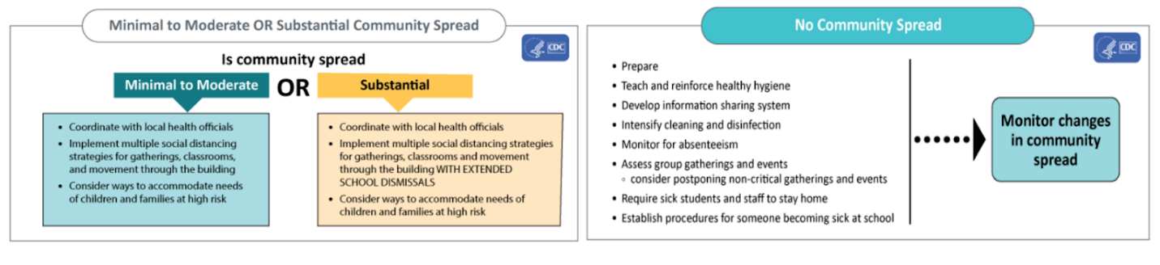
Nevada Rise, in accordance with CDC guidelines, will recommend that all individuals with flu-like symptoms stay home for 72 hours after symptoms resolve, as COVID-19 symptoms can be similar to flu-like symptoms. Recovered COVID-19 patients can return 5 days after recovery or 72 hours after symptoms resolve – whichever is longer. If Nevada Rise suspects a case(s) of COVID-19:

1. Place a face mask on the person immediately, ensuring mask is being properly worn across the bridge of their nose and down to chin
2. Isolate the case in a separate room.
3. Contact local/state health department as soon as possible.
4. Create a list of all (students and staff) who could have been exposed (contacts).
5. Consider hospitalization for those with severe symptoms.

Nevada Rise will follow the advice of the local/state health department regarding reporting, isolation of cases/quarantining contacts, environmental disinfection, individual hygiene, and the probability of school closure.

Finally, Nevada Rise will communicate to staff, parents or guardians, and students that it is critical to be current on all required immunizations.
PHYSICAL HYGIENE
- How will you address and reinforce hand hygiene and respiratory etiquette?
- How will face coverings be used? Please refer to Emergency Directive 024 and the associated guidance which outline the requirements for face coverings.
In 2020, Nevada Rise changed janitorial/sanitation supply vendors to ensure more adequate hygiene protocols and constant supplies for soap and hand sanitizer. Through weekly services and inventory controls, all supplies are stocked.

Hand Hygiene and Respiratory Etiquette: According to the CDC, handwashing is especially important and is one of the best ways to protect and prevent staff and students from getting sick as well as spreading germs. To help mitigate spread of any illness and/or virus, we will take the following measures:
- Nevada Rise will teach and reinforce handwashing with soap and water for at least 20 seconds and increase monitoring to ensure adherence among students, teachers, and staff. If handwashing is not possible, hand sanitizer containing at least 60% alcohol should be used. Hand sanitizer dispensers have been installed for each classroom, in common areas, and outside restrooms. Nevada Rise will dedicate the majority of the first days to routines, including those that establish healthy hand-washing routines and habits. We will review each time students take bathroom breaks, create songs to remind them, and post student-friendly signs and posters to reinforce these habits. We will share these practices with families and assign these same routines as “homework” to practice at home as well.
- We will teach and encourage students and staff to cover coughs and sneezes with a tissue when not wearing a mask and immediately wash their hands after blowing their nose, coughing, or sneezing. Operations will ensure tissues are in each room through weekly walkthroughs.
- Water fountains have been replaced with touchless water bottle filling stations and each classroom has individual water dispensing machines to ensure accountability. Water bottles are also on site in case students forget their own.
- Increased signage for all grade levels is present in all restrooms and outside classrooms to help remind all stakeholders to wash and sanitize hands.

FACILITIES MANAGEMENT: CLEANING & MAINTAINING A HEALTHY SCHOOL
It is our goal at Nevada Rise to provide a learning environment that is productive and safe. Facilities are all-inclusive of any structures on campus. Therefore, addressing safety and security is essential, which includes the cleaning and disinfecting as well as monitoring of access to any room or space within a facility.

As Nevada Rise is in a shared space, we will coordinate with Paradise Church to ensure consistency in standards across all parties.

Facility Adjustments:
- Water fountains have been upgraded to include a touchless water bottle filling station and a dispensing machine in each classroom to limit hallway traffic.
- Hand sanitizer dispensers have been installed throughout the building, including outside each classroom.
- Janitorial supply company changed to ensure adequate supply of appropriate cleaning materials
- Posters and signs are placed strategically through the building to remind all stakeholders of hygiene and safety practices.
- Relocated our front office location and installed barriers for social-distancing, safety, and control.
- Students, as much as possible, except for restrooms and outside, will remain in the same classroom for all subjects and activities. Enrichment teachers, associate teachers, administration, and specialists will transition from class to class.
- All student supplies will be individualized. Each student will have a supply box with necessary materials as well as individual technology devices.

Ventilation:
- Outdoor Air: Each classroom at Nevada Rise includes either a door or window that allows outdoor air to circulate through the classrooms, the kitchen, and throughout the building.
- HVAC Units: HVAC units are dedicated to a maximum of two classrooms, with the majority of rooms having one dedicated unit. This limits the amount of shared air circulated through the building. Filters are replaced twice monthly, well before the recommended replacement cycle.
- Each classroom now has an air purifier capable of cleaning a room of up to 1000 square feet.
- Exhaust fans are installed in each restroom.

Cleaning/Sanitizing Space: In coordination with our contracted janitorial service, we have doubled the time spent on campus to ensure a daily cleaning and sanitation of the facility and classrooms. The following are required daily of the cleaning staff:
- We will have a dedicated staff member to clean bathrooms multiple times daily, as well as assisting with meal service and charged with frequent cleaning and disinfecting of door handles, faucets, keyboards, tables, desks, shared objects, etc.
- Operations associate will be staffed to assist with cleaning duties and meal service.
- We have increased our deep cleaning of classrooms to nightly service, with additional deep cleaning on Fridays.

DETECTING SCHOOL-WIDE OUTBREAKS
School-wide outbreaks will be defined using the Council of State and Territorial Epidemiologists Standardized K-12 school-associated outbreak description:
- Multiple cases comprising at least 10% of students, teachers, or staff, within a specified core group* OR at least three (3) cases within a specified core group* meeting criteria for a probable or confirmed school-associated COVID-19 case with symptom onset or positive test result within 14 days of each other§ ; who were not identified as close contacts of each other in another setting (i.e. household) outside of the school setting; AND epidemiologically linked in the school setting or a school-sanctioned extracurricular activity.

The mechanism used to declare and notify an outbreak and outbreak closures will come from a discussion with the Southern Nevada Health District and we will utilize our school-wide and school-based communication systems. Nevada Rise will utilize Infinite Campus, Class Dojo, and paper-based notifications during arrival and dismissal lines.

If an outbreak is occurs, we will use our current system of record-keeping for all positive cases, daily communication of those who are quarantining or isolating. We will continue to require universal masking and, if needed, close rooms or school buildings using the guidance from the Department of Health and Human Services “2021-22 COVID-19 GUIDELINES FOR PREVENTION AND OUTBREAK CONTROL IN SCHOOL SETTINGS. Additionally, we will use increased sanitizing and cleaning protocols.
Outbreaks will be declared over when the baseline of COVID-19 illness has been achieved for two incubation periods (28 days).
CONTACT TRACING
Nevada Rise will collaborate with the health department, to the extent allowable by privacy laws and other applicable laws, to confidentially provide information about people diagnosed with or exposed to COVID-19. Students, teachers, and staff with positive test results will isolate, and any close contacts will isolate and quarantine in consultation with the Southern Nevada Health District. Nevada Rise will report positive cases to the SNHD as soon as they are informed. School officials should notify families of close contacts as soon as possible after they are notified that someone in the school has tested positive (within the same school day). We will also encourage our families to be communicative of all COVID-19 cases in their individual households and communities.

As addressed above, every person who enters the building will be screened. We are working with our families to ensure they understand that students need to stay home if symptoms of COVID-19 are present. We also message that to teachers and staff. We have staffed our team with the necessary personnel for adequate coverage in the event of an absence. In the event that a community member begins to exhibit symptoms during the school day, those individuals will be isolated while arrangements are made for them to return home.

As mentioned above, Nevada Rise will work with SNHD and, if needed, the SPCSA to facilitate isolation and case investigation. We will fully cooperate with the agencies by providing information and records to aid in the identification and contact of those potentially exposed. Seating charts will be maintained and student seating will remain, to the extent possible, similar in all areas of the school (cafeteria, enrichment classes).

If it has been determined any individuals have been exposed, we will follow the guidelines and directives from the SNHD. All guidelines provided by the Department of Health and Human Services “2021-22 COVID-19 GUIDELINES FOR PREVENTION AND OUTBREAK CONTROL IN SCHOOL SETTINGS will be followed in regards to quarantine and isolation.

If a child with a disability is required to quarantine, Nevada Rise will provide services consistent with federal disability laws. The special education team will ensure all materials and instruction is delivered.

In an effort to raise awareness, Nevada Rise will include vaccination information and availability in our weekly newsletter. Any nearby or known community partner offering vaccines will be highlighted and encouraged.

TESTING
In order to keep our campus safe, Nevada Rise Academy encourages all members of the community to take proactive measures for mitigation, including confirmation of status through testing. Any student or staff should take a COVID-19 test under the following conditions:
- If you have COVID-19 symptoms
- At least 5 days after known or suspected close contact to COVID-19
- For screening (schools, workplaces, congregate settings, etc.)
- Before and after travel
- When asked by a healthcare professional or public health official

Below is a link to access community testing sites.
http://covid.southernnevadahealthdistrict.org/testing/

IN-PERSON LEARNING: STUDENT & STAFF WELL BEING
STUDENT WELL-BEING
Nevada Rise recognizes the need for social-emotional learning (SEL) in response to both the COVID-19 pandemic ad well as the social movements of recent months. We agree with the Nevada Department of Education that “…it is crucial for students and staff to feel connected and schools are in the unique position to be able to bring together educators, staff, students, families, and community partners to cocreate safe, supportive learning environments and an intervention framework where all students and adults can work through the process of coping and healing.”

Curriculum:
- The core curriculum for English Language Arts (EL Education) incorporates SEL components into weekly lessons. Additionally, we are adopting their framework for inclusive school culture, “We Are Crew.” This incorporate elements of restorative circles, collaboration, and character development.
- To address this topic more directly, we have purchased a quality curriculum to guide SEL to ensure multiple resources are available for students and staff. Our curriculum is aligned to the Collaboration for Academic, Social, and Emotional Learning (CASEL) which defines SEL as how children and adults learn to understand and manage emotions, set goals, show empathy for others, establish positive relationships, and make responsible decisions. At least one formal, dedicated, sequential SEL lesson will be delivered weekly. A second SEL curriculum was purchased to supplement as needed.

Partnerships/Resources:
- Nevada Rise is proud to partner with Project AWARE via the SPCSA to incorporate a multi-tiered system of supports (MTSS) for all learners.
- In school year 2020-2021, we partnered with Code Switch to provide our staff training on Restorative Justice and circles to foster a more inclusive learning environment.
- We are also excited to begin a partnership with the Eighth Judicial District Court’s Truancy Diversion Program (TDP) to support students and their families to address students’ school attendance, behavior, and grades. The court staff helps students to focus on the importance of school attendance and grades, including homework completion and appropriate classroom/school behavior, while providing a positive supportive environment.
- A part-time social worker is available to provide resources and support for students and families.
- Additionally, morning announcements will address SEL topics. Our RISE values have been redefined to incorporate more student empowerment and SEL components. Finally, we will communicate these shifts by incorporating them into our established communication systems, highlighting SEL themes in our newsletters, and streamed morning announcements. Our Families for Achievement Council is working to make sure parents have a full understanding of the approach to SEL, behavior management, and DEI.
STAFF WELL-BEING
Nevada Rise has established a Diversity, Equity, and Inclusion (DEI) committee to guide our staff’s work in SEL as well as our approach to behavior management. Our school environment and culture ensures high expectations and predictable routines, but our behavior management systems have been overhauled to ensure a Multi-Tiered System of Supports (MTSS), and Positive Behavioral Interventions and Supports (PBIS). We are working to incorporate dedicated sections of SEL and DEI into weekly lesson planning to frame the work for our educators. The DEI committee is also working to identify appropriate professional development for staff.

Elements found in both Project Aware (MTSS) and We Are Crew will be applied to staff. We have also transitioned to a 4-day per week instructional calendar, affording staff a full day of planning, collaboration, and providing more work-life balance opportunities.

IN-PERSON LEARNING: ACCELERATING STUDENT LEARNING
Accelerating student learning is among our top priorities coming into the 2021-2022 school year. There are a variety of shifts we are making to address this issue.

Professional Development: Given that these are unprecedented times, we are leveraging the strength of professional and academic organizations to help us in the professional development (PD) of accelerating student learning.
- During our two week summer PD, we are partnering with the Relay Graduate School of Education to engage in the following sessions:
  - Building and Affirming Learning Partnerships
  - Accelerating Learning Through Student Work
  - Planning to Address Gaps While Maintaining the Bar
  - Supporting Students Who Are Multilingual in General Education
- Nevada Rise has recently partnered with Bellwether Education to create a three-year strategic plan, including the following components:
  - Data Driven Instruction utilizing daily strategies, weekly analysis, benchmark planning, and incorporating more data in the Response to Instruction (RtI) process.
  - Educator development through targeted observation, feedback, and the coaching process.
- Two of our current partners, Project Aware and Data Insight Partners, will continue to provide PD to staff on utilizing data to drive instructional decisions and increase student achievement, in both academic and cultural components.
- Finally, the full PD days on Fridays will include weekly meetings with an embedded component of data analysis.

Staffing: To assist with learning acceleration, we have created a Intervention Coordinator, charged with ensuring daily small groups and intervention groups are using data to inform instructional activities, tracking progress through consistent progress monitoring systems, and facilitating conversations among and between stakeholders (teachers, associate teachers, parents, special education, and administration). The number of associate teachers per grade level who will work with lead classroom teachers has increased to create more small group learning opportunities to allow for targeted instruction.

ESSER funds have contributed a great deal to ensure we eliminate resource inequity on campus. Student learning materials are provided by Nevada Rise Academy.

DISTANCE EDUCATION: SUPPORTING STUDENTS UNABLE TO PARTICIPATE IN-PERSON
Nevada Rise will ensure a distance education option is always available. This option will be reserved for:
- Students who have documentation from a medical professional related to a condition that would be compromised by attending school in-person or
- Students who are quarantined on the advice of the Southern Nevada Health District or
- Students who have documentation outlining extenuating circumstances that do not allow the student to attend school in-person, and will be decided on a case-by-case basis.

Having provided distance education through a hybrid model during the 2020-2021 school year, each classroom on campus is equipped with the technology to allow any student learning through distance education to join classes virtually. Distance learners are expected to attend the full instructional school day, with breaks for meal service.

Students who are in short-term distance education (in quarantine, for example), will remain with their class. Given the demands of the hybrid model, one classroom per grade level in kindergarten through 2nd grade will serve as the hybrid classroom as to adequately staff the classroom for both in-person and distance learners. This will apply to those students who are in long-term distance education.

All students are provided a Chromebook, and, if needed, a hotspot for internet access. If a student has an IEP or a 504 Plan, all accommodations, modifications, and other requirements outlined in those documents will be followed. Our support services are adequately staffed to ensure all students receive required accommodations. If needed (for long-term distance education), we will work with families to modify the IEP to make it conducive to distance education. During the initial school closure and distance education experience, Nevada Rise adapted support services, and we will continue to enhance these. The special education staff members will maintain:
- Dedicated online classroom (Google Classroom) specifically for students with IEPs.
- Work with our contracted support service team to continue small group and individual therapy, as well as teletherapy, when possible.
- Administration will check lesson plans and observe delivery in all models (distance education and on campus) to ensure goals for individual students are met and lessons aligned with those goals.
- We have established an English Learner support team, with two members ensuring adaptations and accommodations are provided for English Learners
- Students with special needs will have priority in attending in-person or in scheduling video lessons.

Students learning through distance education will have daily direct contact through our classroom communication platform or phone call. In that communication, full nutrition services will be offered. Families will have the option to receive daily meals, or they can receive a full week’s worth of meals at one time. Utilizing MyEducationData, parents can track progress of all students.

DISTANCE EDUCATION: EMERGENCY CLOSURE
Nevada Rise understands that, despite our best efforts to mitigate transmission, there are many factors outside our control. There is also an understanding that there are situations that may occur that lead to temporarily closing schools or parts of a school. These decisions will be guided by the SNHD and based on careful consideration of a variety of factors, prioritizing health and safety of our school and larger community, and secondarily, the academic impact.

As an elementary school, all classes stay in cohorts throughout the day, minimizing contact with students from other classes. In grades 3 and 4, teachers rotate to classrooms to limit traffic in hallways and contact with other classes.

In the event of a closure, Nevada Rise will transition to a synchronous distance learning platform enabling students to continue to learn from home. The infrastructure for such a transition was established and developed during the 2020-2021 school.

Nevada Rise will provide Chromebooks, power cords and headphones to each individual student unless the family chooses to use their own devices. In the event a household needs internet connectivity, Nevada Rise will supply hot spots and devices that run pre-loaded programs without the need for internet.

The synchronous distance learning model incorporates live instruction, through student devices, in both whole group and differentiated, targeted instruction in small groups. Enrichment classes will continue to be offered, as well as nutrition services (as allowed by health officials). Each grade level also maintains a website with recorded lessons for those who miss instruction, and there are a variety of other self-paced learning platforms for students.

Teachers and staff will contact each individual family weekly during any closure. Teachers will have a daily designated time in which they will reach out to families. All teachers will make the attempt and log the outcome on an internal spreadsheet to organize easily. Teachers will be accessible to students during the school's regular instructional hours using Class Dojo as a primary point of contact and text message as a secondary. Associate teachers, operations staff, and student support services will assist in communication.
These records will ultimately be maintained in Infinite Campus.

